|  |  |  |
| --- | --- | --- |
| [Cluster - 2600](https://gnps.ucsd.edu/ProteoSAFe/result.jsp?view=cluster_details&protein=2600&show=true&task=fb333b3fd47f40ba9a0a1aeb88263170" \l "%7B%7D" \t "_blank) | | |
| **Accession** 374   |  |  | | --- | --- | | [**Monoisotopic mas**s](https://www.unimod.org/modifications_list.php?orderby=amono%5Fmass) |  | | -1.007825 |  | | [**Average mass**](https://www.unimod.org/modifications_list.php?orderby=aavge%5Fmass) -1.0079 |  | |  |
| cluster index 2600 |  |
| parent mass 718.283 |  |

ID Rifamycin S

By comparing these 2 spectra, there is a 1.007Da mass difference, which indicates the event of hydrogen loss, which is a common phenomenon in mass spectrometry.

cluster index 2623

parent mass 719.29

ID N/A

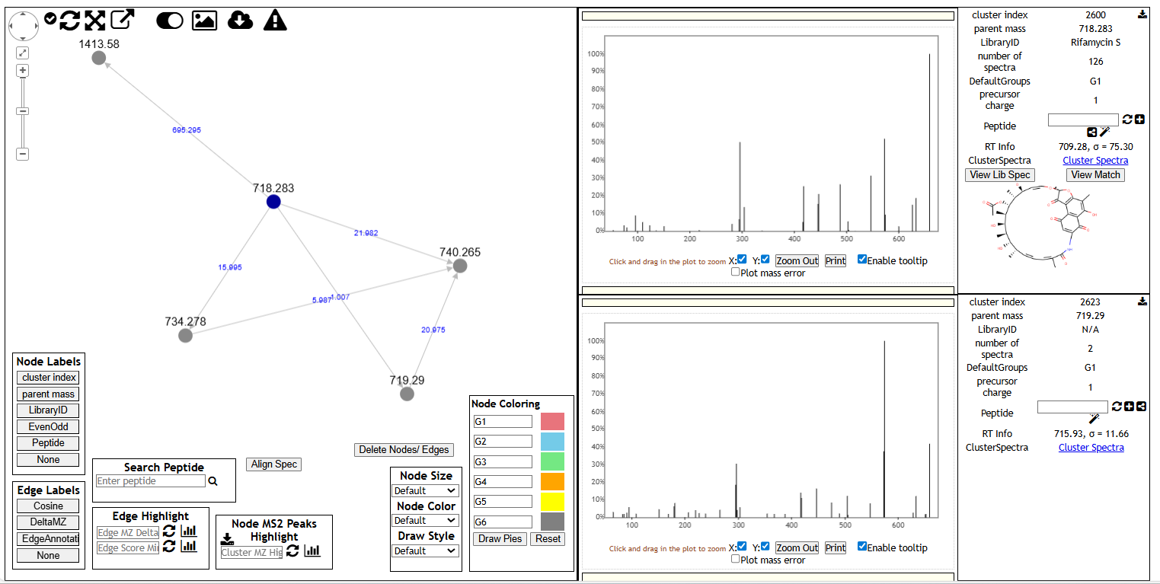

[UCSD Computational Mass Spectrometry Website](https://gnps.ucsd.edu/ProteoSAFe/result.jsp?view=network_displayer&componentindex=64&highlight_node=2600&task=fb333b3fd47f40ba9a0a1aeb88263170#%7B%7D)